**ME119: SHEET 13-3D MODELING AND 3D PRINTING**

**Model: Mirror Cube**

**Group No. 80**

**Name: Sajal Narang(150020036)**

**Aditya Ghasle(150020034)**

**Parts:**

1. **Center Pieces – 6 files**
2. **Center Covers – 1 file (To be printed 6 times)**
3. **Edge Pieces – 12 files**
4. **Corner Pieces – 8 files**
5. **Yoke – 1 file**
6. **Screws – 6 (To be added externally)**
7. **Silver Mirror Stickers (To be added externally)**

**About:**

**The Mirror Cube is a lesser known variant of the Rubik’s Cube. The most noticeable feature of the Mirror Cube which differentiates it from the trivial cube is that it is monochromatic and the sizes of the pieces are different.**

**Description:**

**The way the parts have been made ensures that the final model will be working and will replicate all the degrees of freedom of a regular cube.**

**Resolved:**

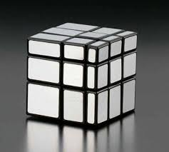

**Unresolved:**

